The

MYSTERY

of

HISTORY

*A unit on China*

Proposed by

*Annie John*

Overview

The Mystery of History

Ancient China

Sneak-peek Reference Guide

|  |  |  |  |  |
| --- | --- | --- | --- | --- |
| Dynasty | Literature | Activity | Lesson | Important Information to Instruct |
| Xia  (2205-1766BCE) | * Tikki Tikki Tembo | * Pinch Pots | * What’s in a Name? | * 440 Years * Some Chinese believed Xia was a legend, until artifacts were found. * Farming began * Pottery developed |
| Shang  (1766-1122BCE) | * Ten Suns | * Soap bar carvings | * Visualization | * 645 Years * First to have written records (shoulder-blades of oxen & shells of turtles): oracle bones * Chariots invented * Silk |
| Zhou  (1122-221BCE) | * Confucius | * Confucius garden | * Confucius Quotes | * 902 Years * Confucius lived 551-479BCE * Developed ion tools, society, money, and written laws |
| Qin  (221-206BCE) | * Cat and Rat | * Great Walls | * Zodiacs | * 16 Years * Unification of China under King Zheng – proclaimed himself “Shihuang Di” meaning “The First Emperor” |
| Han  (206BCE-220CE) | * The Emperor and the Kite | * Kites | * How Characters Change | * 426 Years * Invention of kite * Invention of paper & ink * Silk road opens * Buddhism * Schools built |

**Timeline**

|  |
| --- |
| Topic: |

Xia Zhou Han

Years: Years: Years:

Information: Information: Information:

Shang Qin

Years: Years:

Information: Information:

Xia

Hands-on Activity:

Pottery Making

In this activity, students will make a “pinch pot” with clay.

Materials:

* Air-Hardening Clay (can be found at craft stores)
  + Preparation: separate into Ziplocs; each will need to have approximately a fist-sized mound of clay. Make one per student.
* Hand tools (optional)

Instructions:

1. Discuss with students how the Chinese people developed pottery. This is an invention we still use today. Lead a discussion about what pottery is used for.
2. Have each student take out their clay and knead the lump by squeezing it and pushing it until it is not too soft and not too hard. Roll the lump of clay into a smooth ball. Start squeezing and pressing the ball with the flat side of your fingers from the center of the clay and rotate around it leaving a thick rim. As you are rotating, angle your fingers to create a wide opening. Once this is done you can use the spray bottle and sponge to wet and smooth the bowl, leaving it with no cracks. You can also use the tools to better shape, smooth, and make contour the pot. Afterwards, you can use the tools to make designs in the clay by scratching away at the clay and making engravings.
3. Allow students to take the clay home and let it dry overnight.

Mentor Text Lesson

Text:

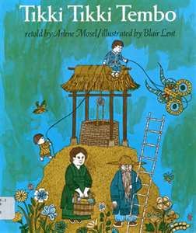

This classic Chinese legend tells the story of a boy who nearly drowns in a well because his brother cannot pronounce his long name fast enough for an old man to save him. The lovely drawings capture the beauty of rural China.

Visualization

**Overview & Purpose**

In this lesson, students will read the folktale Tikki Tikki Tembo. Afterward, they will research their own name and summarize the information in a paragraph.

**Learning Objectives:**

* Understand the term “folktale”
* Utilize technology to research the meaning of their name
* Write a paragraph about their name

**Learning Standards:**

CCSS.ELA-LITERACY.RL.3.2: Recount stories, including fables, folktales, and myths from diverse cultures; determine the central message, lesson, or moral and explain how it is conveyed through key details in the text.

CCSS.ELA-LITERACY.W.3.2: Write informative/explanatory texts to examine a topic and convey ideas and information clearly.

CCSS.ELA.LITERACY.W.3.4: With guidance and support from adults, produce writing in which the development and organization are appropriate to task and purpose

CCSS.ELA.LITERACY.W.3.8: Recall information from experiences or gather information from print and digital sources; take brief notes on sources and sort evidence into provided categories

WA.SOCIAL STUDIES.1.1.1: Understands the key ideals of unity and diversity

**Materials:**

* Copy of Tikki Tikki Tembo, by Arlene Mosel
* Access to internet site: www.behindthename.com
* What’s in a Name? Paragraph Outline Page
* Writing Paper

**Introduction:**

1. Using chart paper or white board, brainstorm with students things we all have in common. Lead the brainstorm to include *we all have a name* if it is not already shared by students.
2. Discuss why students believe we each have a name, and often times, names are different.
3. Inform students that, over the next few days, we will be researching our name. Ask if anyone knows how they got their name, or what their name means.
4. If no students allude to it, inform students that many times, names are based in history and culture. Today, we will be reading about a Chinese folktale about names.

**Practice:**

*Note to teacher: This lesson is intended to be completed in two class periods (to allow for the home extension); however, it can easily be adjusted for the needs of your classroom.*

Literature Component

1. Ask if anyone remembers what a folktale is. *A folktale is a story that’s passed down in generations, that teaches a lesson*.
2. Read Tikki Tikki Tembo
3. Afterward, discuss why this is a folktale and what the people in the story learned.
4. Inform students that we will be looking at our own names to find out why we got them, and what they mean.
5. Distribute the paragraph outline page. Let the students know that we will work on each portion, but for this lesson, we will start with the first two prompts: What is the historical origin of your name?, and what does your name mean? (Note: Teacher should model each portion of the outline prior to students completing it.)

Technology Component

1. Have students access the website: www.behindthename.com
2. In the upper right-hand corner, have students put their first name into the text box and push enter. (Note: teacher should model this for the class)

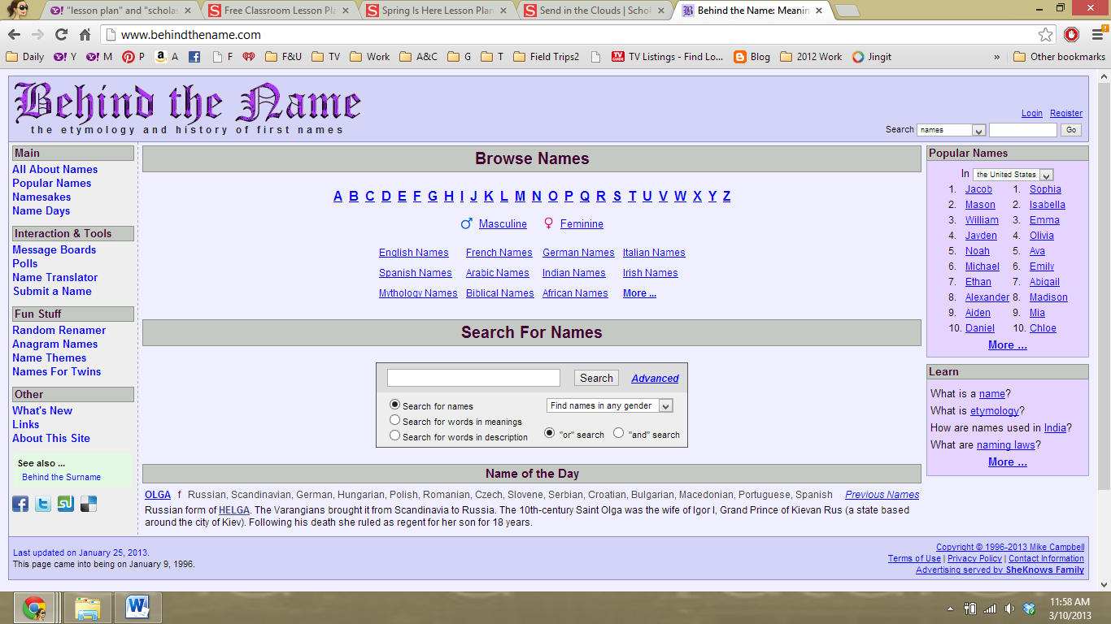

The website will direct you to one of two things. If “Meaning and History” appears, students will be in the correct spot for this portion of the lesson. 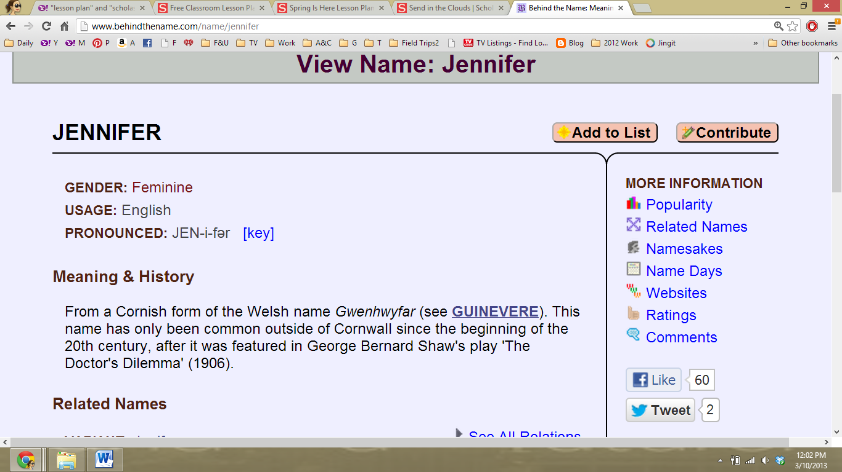

However, students might run into a situation in which their name is a diminutive of a different name. In this case, students will need to click on the diminutive name to discover what their name means.

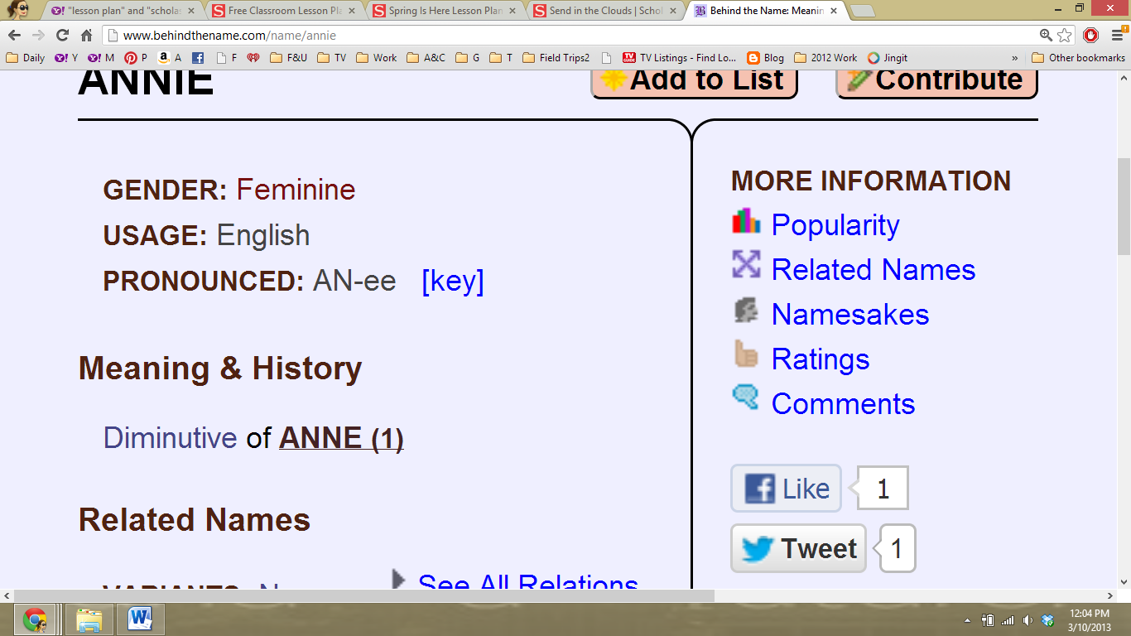

1. Once students have the “Meaning and History,” they can complete the first two portions of their paragraph outline page.
2. Students may optionally research other names of friends, family, celebrities, etc.
3. Have students share out the origins of their names, or other information they found interesting.

Home Extension

1. Tell students that, often times, there is a story behind why we get our name – just like in the book.
2. Tonight’s home extension is to discuss with family about name origins. The essential information students should be guided to find out is who gave them their name, and the reason why they were given it.

Day Two: Writing Component

1. Have students share the story of their name, either in small groups or as a whole class.
2. Discuss with students the last two portions of their outline sheet: another name, and color/image. Model both pieces for the class.
3. Once students have their brainstorm/paragraph outline sheet completed, they are ready to turn their notes into a paragraph.
4. Encourage students to think of a good “hook” for their introductory sentence. This can be in the form of onomatopoeia, asking a question, or restating a quote. Examples:
   1. Hahahahaha! I couldn’t help from laughing when I found out why I’m named SaraLynn.
   2. Did you know that the name Annie comes from London?
   3. “Well….,” my father began, “you were named Carl because of my roommate in college. Let me tell you the story.” He proceeded to tell me all about Carl, and how much Carl loved science.
5. Students write a paragraph about their names, using their outline as a guide.
6. Through the revising and editing process, students finalize their work.
7. Students publish their writing. Publication Idea: Students draw a self-portrait on one half of an 11x14 page, and publish their paragraph on the other side.
8. Have students share out, either in small groups or whole-group, their paragraphs.

**Assessment:**

Assessments are aligned with the learning targets:

CCSS.ELA-LITERACY.RL.3.2: Formative assessment during discussions before/during/after reading the mentor text.

CCSS.ELA-LITERACY.W.3.2: Evaluate paragraph for understanding and how the topic is conveyed.

CCSS.ELA.LITERACY.W.3.4: Evaluate paragraph for task and purpose

CCSS.ELA.LITERACY.W.3.8: Evaluate paragraph outline for gathering information from digital sources

WA.SOCIAL STUDIES.1.1.1: Formative assessment during discussions regarding culture, how we are all different, and how we are all similar.

What’s in a Name?

Paragraph Outline

|  |  |
| --- | --- |
| What is the **historical origin** of your name? |  |
| What does your name **mean**? |  |
| **Who** gave you your name? Do you know why? If so, explain. |  |
| Have you ever wanted **another name**? Why or why not? |  |
| What **color** or **image** comes to mind when you say your name out loud? Why? |  |

Shang

Hands-on Activity:

Soap Bar Carving

In this activity, students will carve bars of soap to relay a picture or a message.

Materials:

* Bars of Ivory soap (one per student)
* Carving tools, including but not limited to:
  + Sharp pencil
  + Unsharpened (flat ended) pencil
  + Wooden craft sticks
  + Paperclips

Directions:

1. Discuss with students how the Chinese, during the Shang dynasty, were the first to have written records. Inform students of how they used shoulder blades of oxen and shells of turtle, called oracle bones, to write on.

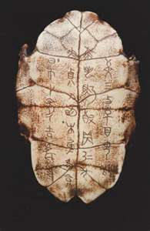 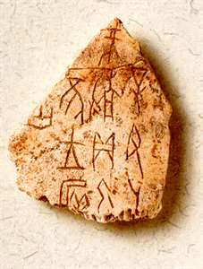 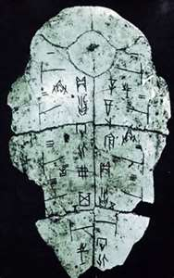

1. Review safety rules
2. Have students sketch a simple version of their design into the soap using a sharp pencil.
3. Carve the design using the carving tools. The sharp pencil may carve the finer details of the sculpture.
4. Note: It is important to wipe soap away from the carving tools as students carve to help maintain a clean carving edge.
5. Allow students to bring home the carvings.

Mentor Text Lesson

Text:

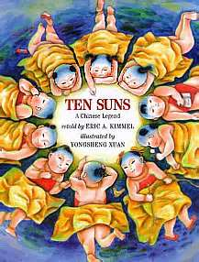

According to a Chinese legend, Di Jun, the god of the eastern sky, has 10 children. Each day, the 10 suns take turns crossing the heavens. The people of the Earth bless them in their prayers, and all is well, until the day the boys take it into their heads to cross the sky all together. With 10 suns shining down, crops wither and burn, seas boil, and people faint on the scorched ground. A great hero, Hu Yi, comes to the rescue. The mighty archer shoots down nine suns, leaving one to warm the Earth. The falling suns become crows, who now greet their brother every morning as he rises to cross the sky.

What’s in a Name?

**Overview & Purpose**

In this lesson, students will focus on creating a mental picture. While the teacher is reading the story, students illustrate a scene that inspires them.

**Learning Standards:**

CCSS.ELA-LITERACY.RL.3.2: Recount stories, including fables, folktales, and myths from diverse cultures; determine the central message, lesson, or moral and explain how it is conveyed through key details in the text.

CCSS.ELA-LITERACY.RL.3.7: Explain how specific aspects of a test’s illustrations contribute to what is conveyed by the words in a story.

WA.SOCIAL STUDIES.1.1.1: Understands the key ideals of unity and diversity

**Materials:**

* Copy of Ten Suns by Eric A. Kimmel
* White paper (for illustrating)
* Illustration tools (pencil, pen, crayons, markers, etc.)

**Introduction:**

1. Discuss with students what it’s like to create a mental picture.
2. Have students close their eyes; teacher orally lists things the students can picture in their minds. Ideas include:
   1. Birthday cake
   2. Driving in the car with the windows down
   3. Their best friend’s smile
   4. Their favorite food
3. Discuss with students the importance of being able to create a picture in their brain while they’re reading.

**Practice:**

1. Distribute materials to each student – drawing paper and pencil, at a minimum. *Teacher note: you may allow crayons and/or markers, depending on your style.*
2. Inform students that their task, while you are reading, is to draw a picture of a passage in the book that they created a mental picture with.
3. Read the book Ten Suns. While you are reading, **do not** show any illustrations. Encourage students to draw their favorite scene.
4. Allow extra time for students to finish their illustrations
5. When students are done, have them write on the back of their picture what passage they illustrated.
6. Share illustrations via a gallery walk, small groups, whole groups, or other method.
7. Read Ten Suns again; this time, show the book’s illustrations as you read.
8. Discuss with students why our mental pictures can be different than each other’s, even when the passage is the same.

**Assessment:**

Assessments are aligned with the learning targets:

CCSS.ELA-LITERACY.RL.3.2: Formative assessment during discussions before/during/after reading the mentor text.

CCSS.ELA-LITERACY.RL.3.7: Evaluate how thestudents’ illustrations relate to the text.

WA.SOCIAL STUDIES.1.1.1: Formative assessment during discussions regarding culture, how we are all different, and how we are all similar.

Mooncake

A recipe for mooncakes, the Chinese snack traditionally served during the Moon or Mid-Autumn Festival.

The story dates back to ancient China when ten suns once appeared in the sky. The Emperor at the time requested that the nine extra suns be shot down by an expert archer. The reward was a pill from the Goddess of the Western Heaven, which would make the archer immortal. However, his wife took the pill and was punished by being banished to the moon. Her beauty comes out to shine during the Moon festival. This is one of many Moon Festival legends.

### Prep Time: 20 minutes

### Cook Time: 20 minutes

### Total Time: 40 minutes

### Ingredients:

Filling:

* 1 pound red azuki beans
* water
* 3/4 cup lard or oil
* 1-3/4 cups sugar
* Water-Shortening Dough:
* 2 cups flour
* 5 tablespoons lard
* 10 tablespoons water
* 1/4 teaspoon salt

Flaky Dough:

* 1 cup flour
* 5 tablespoons lard
* red food coloring for design

### Preparation:

Filling Instructions:

Soak red beans in water to cover 2 hours. Drain and discard the water. Cover with 8 cups fresh water and bring to a boil, then simmer over low heat 1-1/2 hours or until skins open. Strain the beans and discard the skins. Place the strained beans in several layers of cheesecloth and squeeze out any excess water.

Place in a saucepan with the lard or oil and the sugar. Cook, stirring continuously, until almost all the moisture has evaporated. Let cool.

Dough Instructions:

You will need 2 cups of filling for the mooncakes. Divide this into 20 portions and shape into balls. Mix ingredients for the water-shortening dough and the flaky dough separately until smooth. Divide each dough into 20 equal portions.

Wrap one portion of flaky dough inside each portion of water-shortening dough. Roll out each piece of dough, then fold in thirds to form three layers. Roll out again, and once more fold in thirds to form three layers.

Flatten each piece of dough with the palm of your hand to form a 3" circle. Place one portion of filling in the center. Gather the edges to enclose the filling and pinch to seal. Place the filled packet in the mold, gently pressing to fit. Invert and remove the mold.

Dilute red food coloring with water and pour onto a damp paper towel on a plate. Take some food coloring onto the cookie-design stamp, then press on top of the mooncake.

Repeat process for remaining mooncakes. Arrange mooncakes on a baking sheet. Bake 20 minutes at 350 degrees. Let cool before serving.

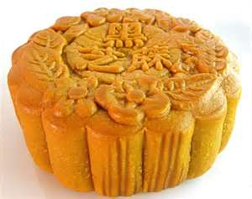 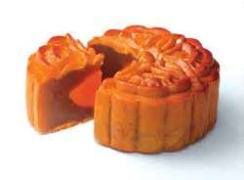

Zhou

Hands-on Activity:

Confucius Garden

In this activity, students will create a small potted garden.

Materials:

* For each student:
  + Pie pan or other shallow dish
  + Dirt
  + Rocks, twigs, sticks, moss, etc.
  + Grass seed

Directions:

1. Discuss with students how many philosophers discussed their ideas with friends and followers, and many of the conversations took place in gardens.
2. Outside, have students gather items to place in their garden. This “gathering walk” should be an opportunity for students to collect rocks, twigs, sticks, moss, small flowers, etc.
3. Distribute materials.
4. Fill the pie pans with dirt.
5. Use the items collected during the gathering walk to create a design in the dirt garden.
6. Sprinkle grass seed in the empty spaces.

Literature Lesson:

A Philosopher’s Mind

**Overview & Purpose**

In this lesson, students will read and learn about Confucius. In addition, they will analyze a variety of his statements.

**Learning Standards:**

CCSS.ELA-LITERACY.RL.3.2: Recount stories, including fables, folktales, and myths from diverse cultures; determine the central message, lesson, or moral and explain how it is conveyed through key details in the text.

CCSS.ELA-LITERACY.W.3.2: Write informative/explanatory texts to examine a topic and convey ideas and information clearly.

**Materials:**

* Copy of Confucius pages, one per student
* Copy of Confucius quotes, one per student
* Copy of graphic organizer, one per student

**Introduction:**

1. Ask students if anyone has heard of the “Golden Rule.” Discuss with students what it means to them.
2. Read about Confucius, either as a whole group, in small groups, or independently.
3. Discuss with students what they learned, and what the most interesting piece of information was.

**Practice:**

1. Pass out the quotes page. Have students select a quote that is meaningful for them, and complete the graphic organizer.
2. When students are finished, have them share their organizer.

**Assessment:**

Assessments are aligned with the learning targets:

CCSS.ELA-LITERACY.RL.3.2: Formative assessment during discussions before/during/after reading the text.

CCSS.ELA-LITERACY.W.3.2: Evaluate graphic organizer for understanding.

**Confucius Quotes**

* Everything has its beauty, but not everyone sees it.
* Forget injuries, never forget kindnesses.
* I hear and I forget. I see and I remember. I do and I understand.
* It does not matter how slowly you go so long as you do not stop.
* Respect yourself and others will respect you.
* When anger rises, think of the consequences.
* Wheresoever you go, go with all your heart.
* Hold faithfulness and sincerity as first principles.

Name:

Confucius Says: Confucius Means:

My illustration:

Qin

Hands-on Activity:

Building the Great Wall

In this activity, students will create a paper version of the Great Wall of China.

Materials:

* Copy of the papercraft – either one set for each student, or enough for each student to do one piece of the papercraft.
* Scissors
* Glue
* Crayons/markers

Directions:

1. Discuss with students the history of the Great Wall of China (see attached page, or use personal resources.
2. Trace the dark lines of the pictures with a Sharpie or other thin, black marker.
3. Have students color the pictures.
4. Cut the pictures out. Note that the directions use a utility knife; however, students should use scissors for this cutting.
5. Fold and glue G07 according to directions.
6. Glue G07 and G02 together according to the directions.
7. Fold and glue G09, and then glue G09 and G03 together according to the directions.
8. Glue the above parts and G01 together according to the directions.
9. Glue G05, G06, G07, and G08 to the above parts according ot the directions.
10. Glue G11 to the above parts to form the base.
11. Fold and glue G04.
12. Glue G04 to the top of the Great Wall.
13. This completes one section of the wall. Feel free to connect as many sections as you see fit.

**The Great Wall of China**

Did you know that the Great Wall of China wasn’t originally one big wall? Around 221BCE, Emperor Qin unified many parts of China. Before that, individual areas had built their own wall defenses to keep their cities safe. By connecting the small parts of the wall, Emperor Qin had a better barricade to protect his people from Mongol invaders to the North.

Most of the original wall no longer exists. Over the centuries, each dynasty developed and repaired the wall based on their needs. The Ming dynasty (1368-1644) carried out a major rebuilding project and extended the wall. It is now approximately 6,000 kilometers (3728 miles) long – which is longer than the distance between Seattle and New York City!

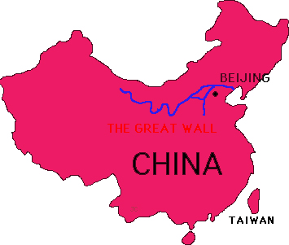 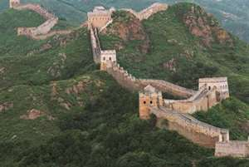

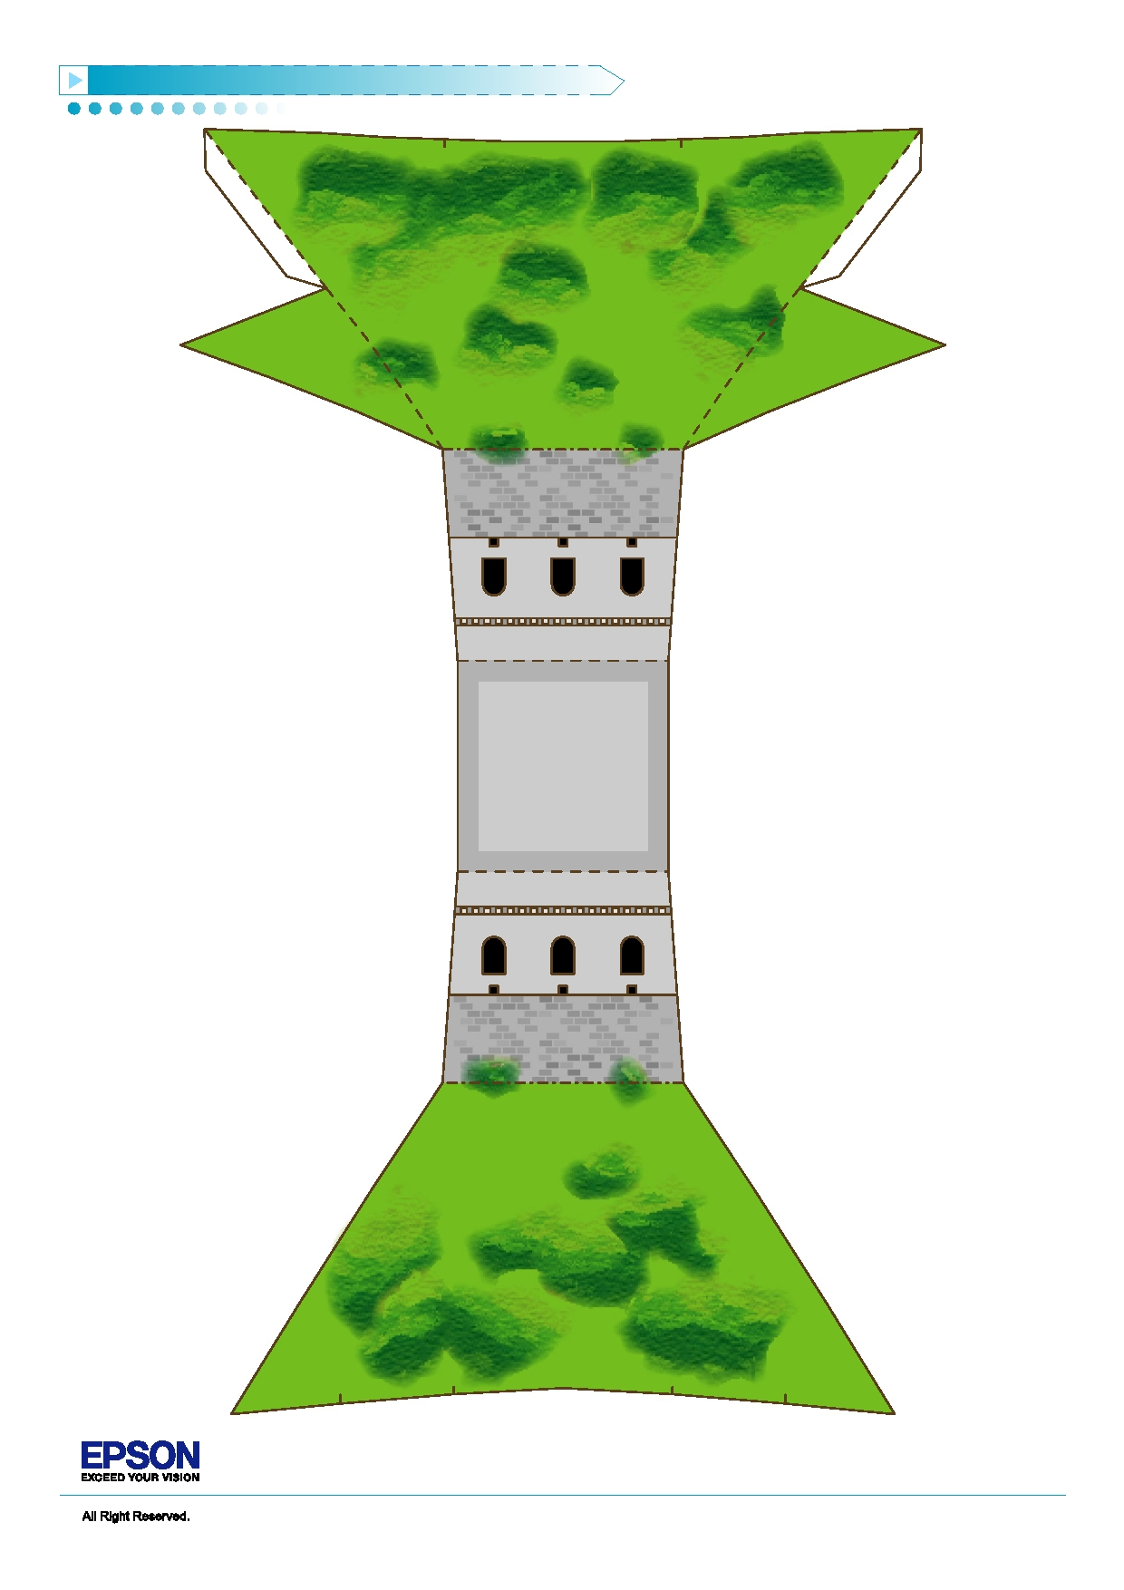The Great Wall in China Papermodel PA P E R C R A F T D E S I G N b y C h a n S e e L i k P a u l

G01

Page 1

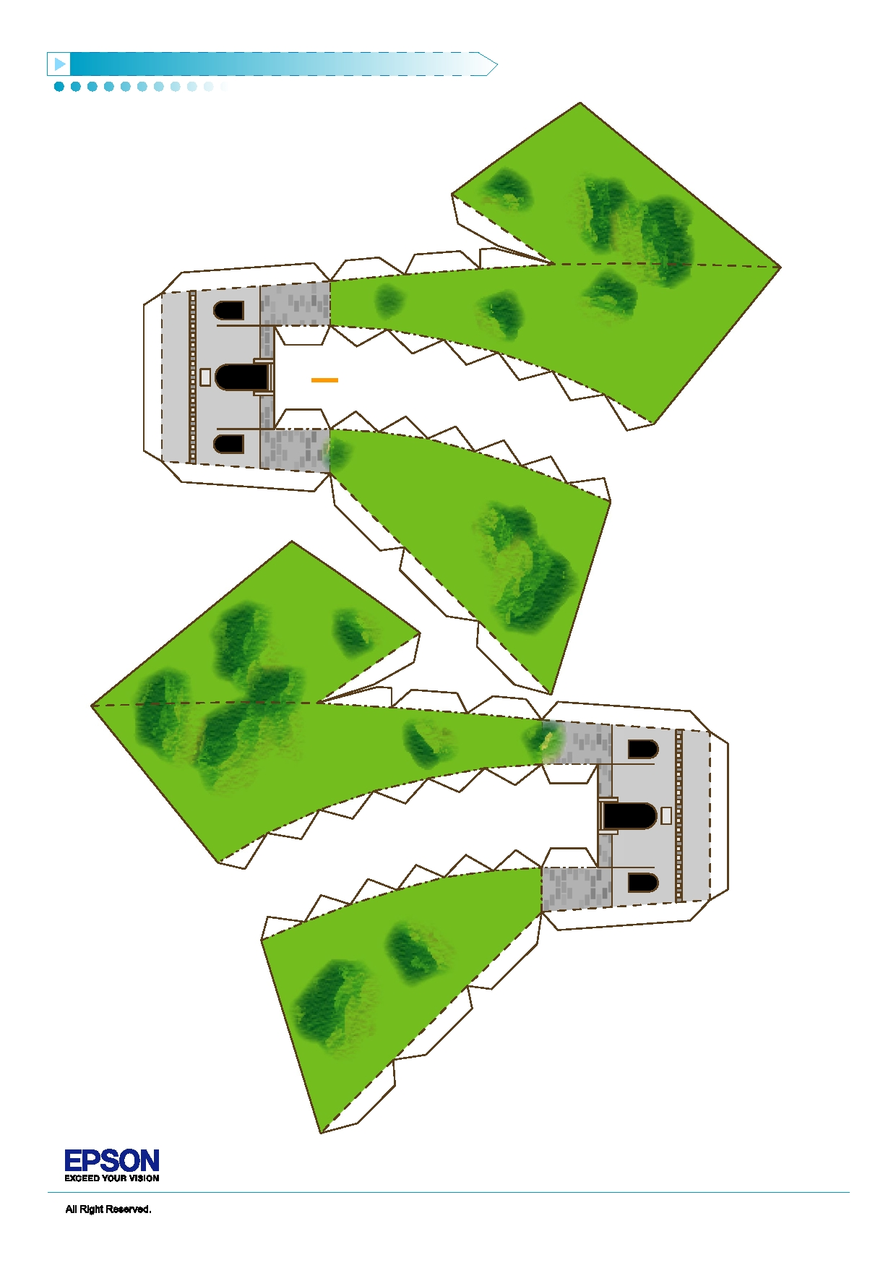The Great Wall in China Papermodel PA P E R C R A F T D E S I G N b y C h a n S e e L i k P a u l

G02

G03

Page 2

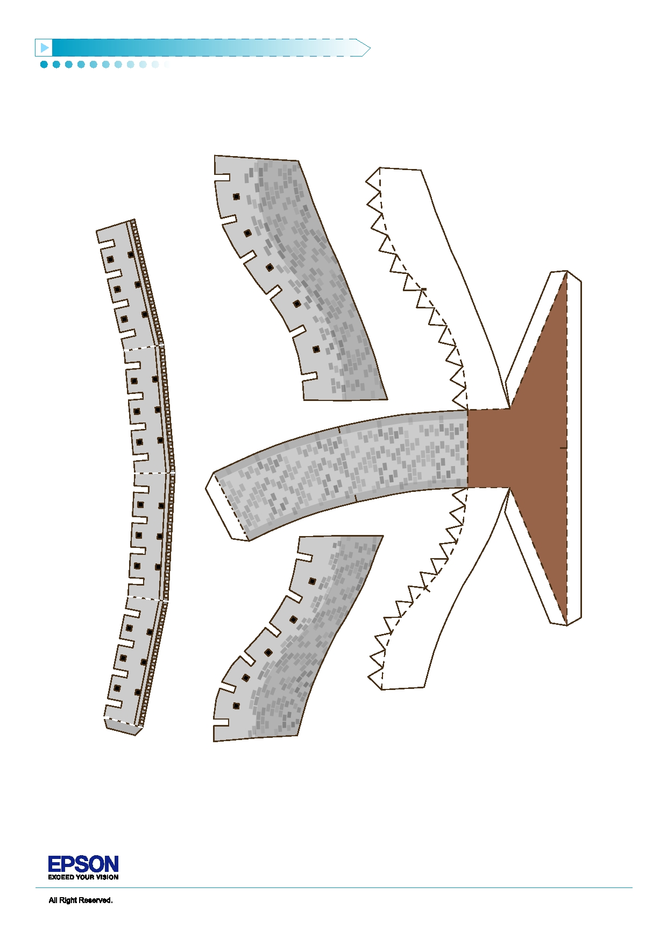The Great Wall in China Papermodel PA P E R C R A F T D E S I G N b y C h a n S e e L i k P a u l

G07

G05

G04

G06

Page 3

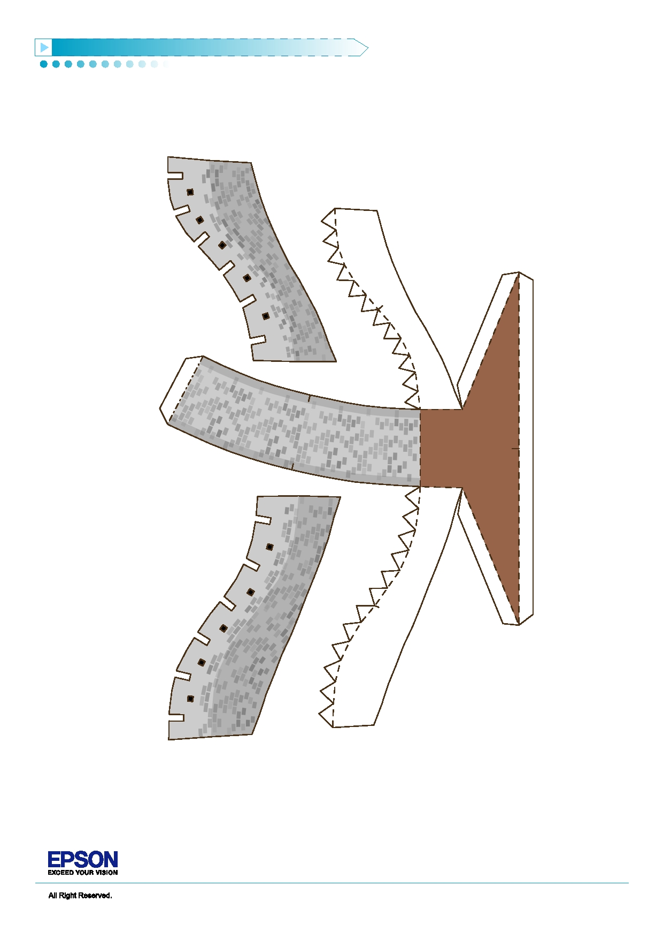The Great Wall in China Papermodel PA P E R C R A F T D E S I G N b y C h a n S e e L i k P a u l

G08

G09

G10

Page 4

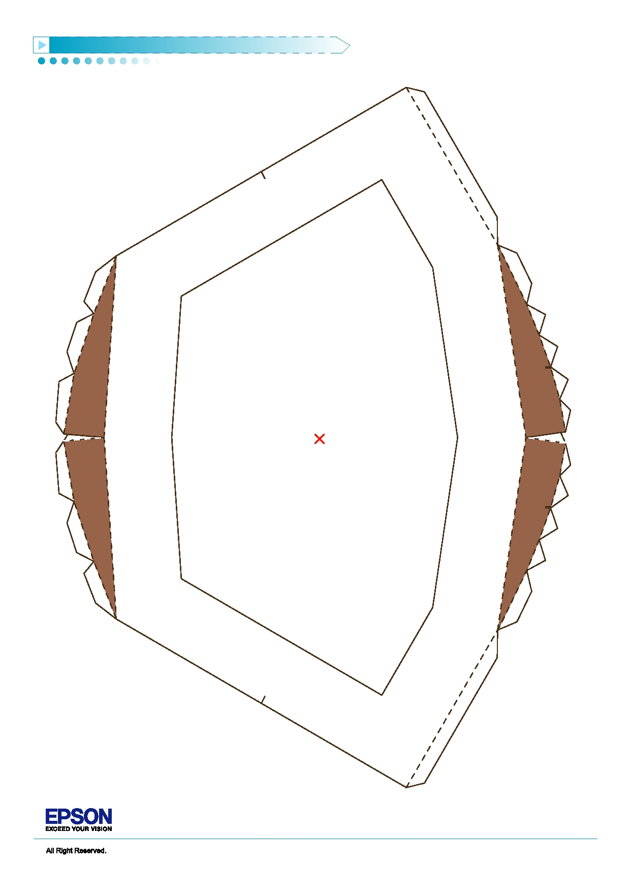The Great Wall in China Papermodel PA P E R C R A F T D E S I G N b y C h a n S e e L i k P a u l

G11

Page 5

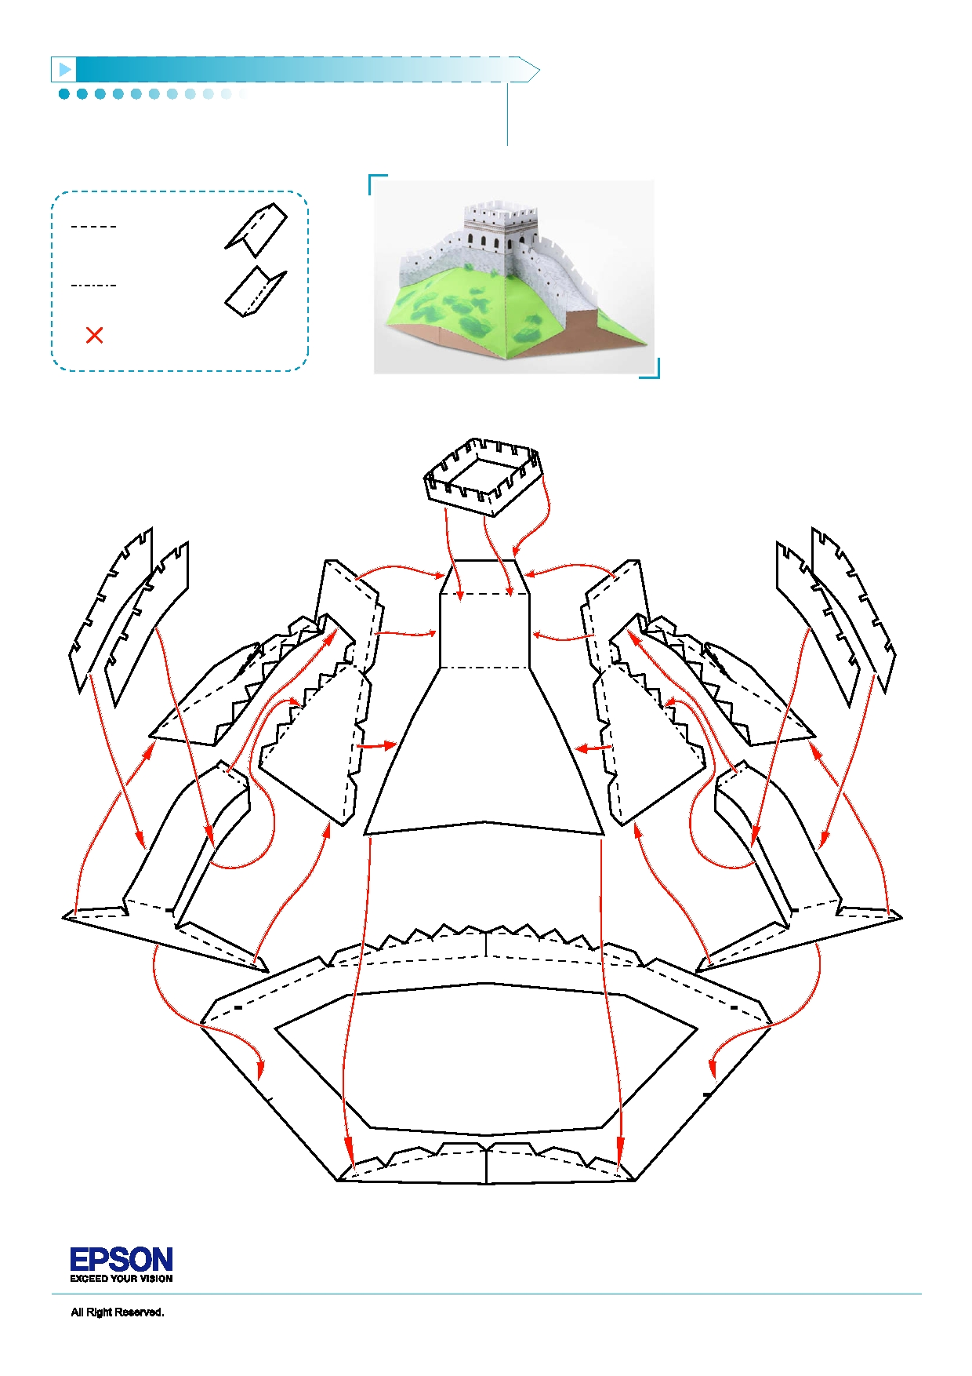The Great Wall in China Papermodel PA P E R C R A F T D E S I G N b y C h a n S e e L i k P a u l

Assembly Instructions

Outward fold

Inward fold

Cut away parts

G04

G10 G05

G08 G06

G01

G03 G02

G09 G07

G11

Page 6

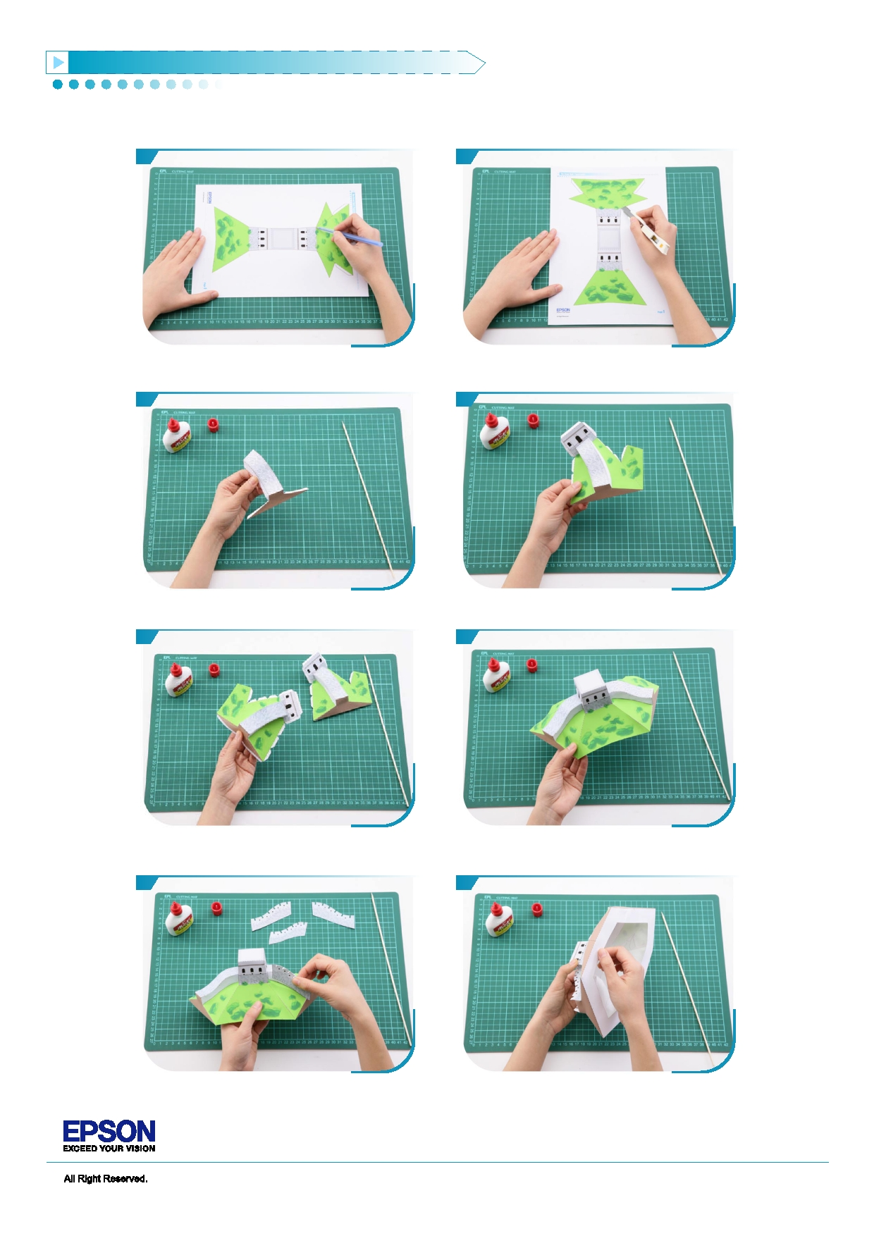The Great Wall in China Papermodel PA P E R C R A F T D E S I G N b y C h a n S e e L i k P a u l

Basic steps

1 2

Use a pen whose ink has dried out, or a tracer, to trace Separate all parts along the lines. Mark their identity on lines first. the back to avoid confusion.

3 4

Fold and glue G07. Glue G07 and G02 together.

5 6

Fold and glue G09, and then glue G09 and G03 Glue the above parts and G01 together. together.

7 8

Glue G05, G06, G07 and G08 to the above parts Glue G11 to the above parts to form the base. according to the assembly instruction.

Page 7

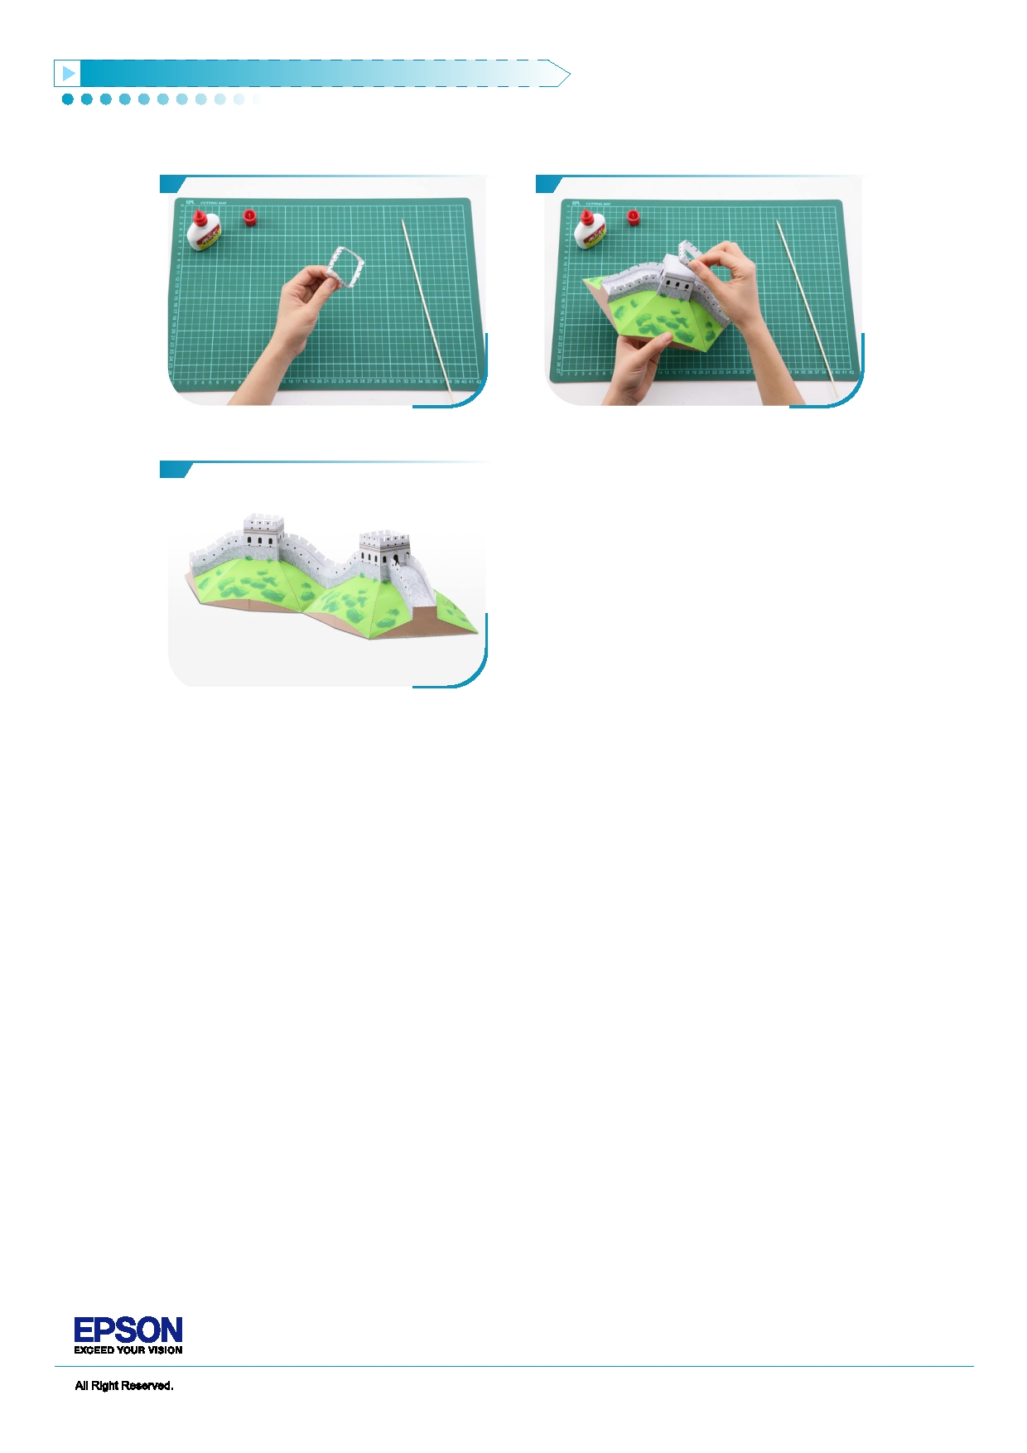The Great Wall in China Papermodel PA P E R C R A F T D E S I G N b y C h a n S e e L i k P a u l

9 10

Fold and glue G04. Glue G04 to the top of Great Wall

11

Repeat the above steps 1 to 10. The Great Wall is now

done.

Mentor Text Lesson

Text:

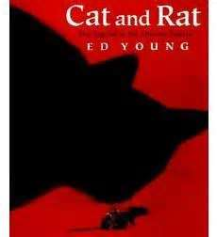

In this version of the story behind the Chinese zodiac, the Emperor challenges all of the creatures to a race through forest and river, saying he will name each of the 12 years in the cycle after the winners. Rat and Cat, the best of friends, ask the water buffalo to carry them across the river. In sight of the finish line, Rat pushes Cat into the water and jumps off the buffalo's back, coming in first. "And that is why, to this very day, Cat and Rat are enemies."

Chinese Zodiacs

**Overview & Purpose**

In this lesson, students will learn about the Chinese zodiac.

**Learning Standards:**

CCSS.ELA-LITERACY.RL.3.2: Recount stories, including fables, folktales, and myths from diverse cultures; determine the central message, lesson, or moral and explain how it is conveyed through key details in the text.

WA.SOCIAL STUDIES.1.1.1: Understands the key ideals of unity and diversity

**Materials:**

* Copy of Cat and Mouse by Ed Young
* Zodiac paper
* Animal pages
* Illustration tools (pencil, pen, crayons, markers, etc.)

**Introduction:**

1. Discuss with students the importance of the Chinese zodiac. It is an important factor to the Chinese culture. The signs have been used for thousands of years as a way of dating years in a 12-year cycle of the Chinese calendar. The importance of the zodiac and the Chinese culture is that the animal signs have been used in stories and folklore. These developed the different personality traits that were represented with each animal. Still today, millions of people in China believe these predictions. The Chinese zodiac plays an interesting role in influencing the culture and community of China.

**Practice:**

1. Distribute a zodiac paper to each student.
2. Talk about the animals found on the zodiac, and what the students already know about the animals.
3. Pose the question, “Why do you think these animals were chosen? Why do you think they are in this order?” Have students discuss.
4. Read the book, Cat and Mouse.
5. Discuss with students what they learned about the Chinese zodiac.
6. Talk about how zodiac traits are assigned based on birth year. Have students discover which animal their year correlates with. Pass out animal pages.
7. Have students compare and contrast the predicted traits with their personality traits using a T-chart. Early finishers can color the pages.
8. Share out students’ T-charts.

**Assessment:**

Assessments are aligned with the learning targets:

CCSS.ELA-LITERACY.RL.3.2: Formative assessment during discussions before/during/after reading the mentor text.

WA.SOCIAL STUDIES.1.1.1: Formative assessment during discussions about the zodiac.

Han

Hands-on Activity:

Kite Making

In this activity, students will create kits out of dowels, trash bags, and string.

One set of materials are needed per student:

* 1/8 inch dowel, cut 30 inches long.
* 1/8 inch dowel, cut 24 inches long.
* Masking tape
* Plastic trash bag
* Kite string

Directions:

1. Place the dowels perpendicular to each other to form a cross shape. The shorter dowel should be about 2/3 of the way to the top of the longer one. Tape them together in the middle by wrapping several strips of masking tape diagonally around the point where they cross.
2. Cut along the seams of a trash bag, so you end up with a flat sheet of plastic. Lay it flat on a table, desk, or floor.
3. Place the dowels on top of the trash bag. Use several small strips of masking tape to tape them onto the trash bag every few inches. Tape the end of each dowel to the trash bag.
4. Cut the excess trash bag from the tip of each dowel to the tip of the next one, to create a diamond shape.
5. Poke a small hole in the trash bag right in front of the point where the sticks cross. Thread kite string through it and tie it around the sticks. Double knot the string.
6. If desired, decorate the plastic bag using permanent markers.

Mentor Text Lesson

Text:

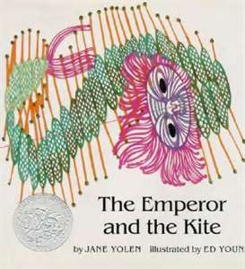

Largely ignored by her own family, Princess Djeow Seow spends her days playing with a kite made from paper and sticks. But when the Emperor is imprisoned in a high tower, only the Princess can save the day, flying her kite high up into the sky to rescue her father.

How Characters Change

**Overview & Purpose**

In this lesson, students will focus on character development and how a character’s actions contribute to the sequence of events.

**Learning Standards:**

CCSS.ELA-LITERACY.RL.3.2: Recount stories, including fables, folktales, and myths from diverse cultures; determine the central message, lesson, or moral and explain how it is conveyed through key details in the text.

[CCSS.ELA-Literacy.RL.3.3](http://www.corestandards.org/ELA-Literacy/RL/3/3/):  Describe characters in a story (e.g., their traits, motivations, or feelings) and explain how their actions contribute to the sequence of events

**Materials:**

* Copy of The Emperor and the Kite by Jane Yolen
* Story Map Page

**Introduction:**

1. Let students know that, in The Emperor and the Kite, they will read about a ruler who learns an important lesson from his smallest daughter.
2. Discuss how a good leader should act. Record responses in a graphic organizer.
3. Discuss the following questions. Record responses.
   1. What kinds of responsibilities does an emperor have?
   2. Why someone would want to be an emperor?
   3. Why should an emperor treat people equally?
4. Read The Emperor and the Kite.

**Practice:**

1. Check with students to see if their responses to the previous questions have changed.
2. In their journals (or other method of response), have students respond to the following prompts:
   1. How does Djeow Seow save her father, the emperor?
   2. Why is the character of the monk important to the story?
   3. Why did people think of Djeow Seow as insignificant?
   4. What do you think would have happened if Djeow Seow did not try to save her father?
   5. Do you think people can learn something important from this folktale? Explain your reasoning.
3. Discuss student’s responses in small groups or another method of your choice.

**Assessment:**

Assessments are aligned with the learning targets:

CCSS.ELA-LITERACY.RL.3.2: Formative assessment during discussions before/during/after reading the mentor text.

[CCSS.ELA-Literacy.RL.3.3](http://www.corestandards.org/ELA-Literacy/RL/3/3/):  Evaluate journal responses for understanding.